**Requirement Analysis Report**

1. **Introduction**
   1. **Project Title**

Haberimdesin

* 1. **Project Definition**

We have a project that is based on android and web application. The application makes people able to share and allows them to be aware of te situation of their cities and also to get help and help each other between users immediately.

* 1. **Project Goal**

Haberimdesin is a nationwide non-governmental organization established to know the problems of the people in that city and it provides a platform for sensitive people to combat the problem.

* 1. **Project Scope**

The main motivation of this project is to provide a platform for citizens to make each other be aware of the situation of their cities and to make a difference on their own. The users of Haberimdesin will be able to share their news and see the news which are close to their location (users can choose the diameter and see the news in that specific location). The project will be completed by January, 2016. We have enough resources to bring this project to life.

* 1. **Application Areas**

The application allows users to share and view contents such as emergency news, infrastructure news, transportation news, sports news and municipal news in specific cities. In addition to that, there will be a feature which informs users(citizens) about upcoming events like concerts, festivals, shortages etc. Thus, this application applies to all people in the city, basically from governor to a grocer.

* 1. **Background**

There are also lots of newswire web sites or android app but our project is unique in the field of itself. The difference of our Project is that it is not a newswire , this is such a social media because the users of Haberimdesin will be able to share their news ,see the news and also they can choose the diameter and see the news in that specific location which are close to their location.

1. **Team Organization**

**Project Manager**

  Sinem KARAMANOĞLU

**Project Group**

|  |  |
| --- | --- |
| **Members of Team** | **Tasks** |
| Halil Mert Açıkportalı | **Responsible for Mobile Application Progress** |
| Sinem Karamanoğlu | **Responsible for Web GUI Progress** |
| Furkan Özbay | **Responsible for Mobile Application Progress** |
| Ahmet Öztürk | **Responsible for Web API Progress** |
| Fatih Furkan Arslan | **Responsible for Database Design Progress** |
| Metin Bulak | **Responsible for Database Design Progress** |
| Gamze Selvili | **Responsible for Web GUI Progress** |
| Nadir Gözcü | **Responsible for Web API Progress** |

1. **Project Schedule**

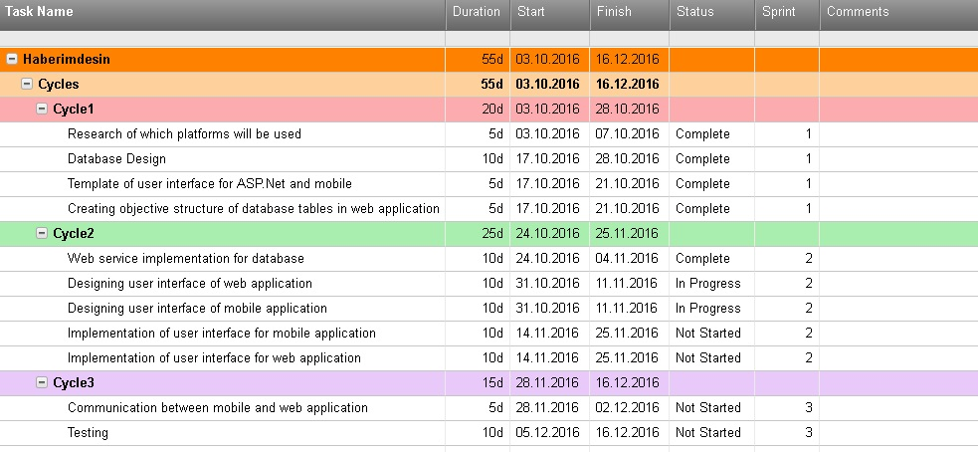

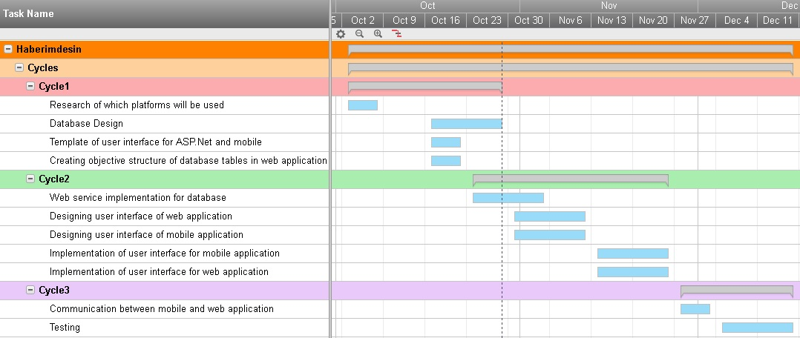

1. **Process Model**

Evolutionary Model

1. **System Requirements**
   1. **Functional Requirements**

- It must be an account system which includes user‘s personal and city informations.

- Users should be able to share news which include images about their own cities.

- According to system user’s locations, users should be able to see news about spesific area.

- Users should be able to see news in diffirent catogories.

- Users should be able to vote depending on their own likings and see the like and the unlike counts.

- Users should be able to make a comment on news.

* 1. **Non-functional Requirements**

           i. **Performance**

   Our system is able to handle over 1.000 requests per secondbecause our sytem is deployed in one of the best hosting and domain company which named GoDaddy.

          ii. **Scalability**

Our system runs on one server machine for over 1.000 users. For more users we can build active – active server cluster and we will use load balancer. So that, we can scale our system easily.

         iii. **Security**

We backup our whole data every day, so if there will be any kind of attack, we can just load latest backup and continue. In addition, users’ and administrators’ data are stored in encrypted type.

**iv.  Maintainability**

Our system runs on web and mobile side. Web application was written in ASP.NET MVC Core and  mobile application was written in Android.

Users who want to use android application, have to have a mobile phone that runs Android 4.4 or higher Android versions.

**v.  Usability**

Our website and mobile application are  easy to use. Website is designed for simplicity and it has modern interface. Our mobile application is designed based on material theme. It brings simplicity and speed.

Our web site is simple and elegant thanks to Asp.NET and Bootstrap. Bootstrap provides us responsive design, Asp.NET provides us to make webpages easier.

**vi.  Availability**

Our system is stored in powerful and World-wide spread company which is GoDaddy. GoDaddy’s machines have 99% uptime and in case of deploying new versions of our software, our system has less than one hour downtime per two months.



**ENGINEERING FACULTY**

**COMPUTER ENGINEERING**

**BIM423**

**SOFTWARE ENGINEERING**

**FALL TERM**

**SEMESTER PROJECT**

**MIDTERM REPORT**

**Instructor:** Assoc. Prof. Dr. Özgür YILMAZEL

**Teaching Assistant:** Res. Asst Muhammet Yasin PAK

**Student:** 58141160848 -AHMET ÖZTÜRK

**Group 1**